Deacon Minutes –un- Approved
9 August 2016

Present: Mary Lancaster, Paula Willis, Pam Parker, Cindy Taylor, Ethan Funk, Teri Burgen, Ishi Stackpole, Gail Stewart, Don Vande Polder and Pastor Cable

Absent: Matt Armstrong

Opening Prayer: Ritchey Cable

Meeting Opened: 6:33 pm

July’s Deacon Minutes: Approved as written. Ordered to be sent out to the Deacons, Session and Office Staff.

Pastor’s Report

- Ritchey is preparing for fall series (M.D.) and asked for input about strengths and areas where there may be room to grow
  - Categories
    - Initial Care (EMS)
      - Reaching out to those who need help
      - Blessed are the poor in spirit…
    - Critical Care (ER/ICU)
      - Counselling and Mercy
      - Caring for those suffering from deep wounds of the fall
      - Blessed are those who mourn…
    - Nourishing Care (Hospital)
      - Feed on the Word of God
      - Growth
      - Blessed are those who hunger and thirst…
    - Strengthening Care (Rehab)
      - Challenge to serve
      - Push beyond comfort zone
      - Blessed are the merciful/pure in heart…
    - Future Care (Medical School)
      - Intentionally investing and training people to go out
      - Leadership development
      - Blessed are the peacemakers/persecuted…
  - Areas felt to be strongest Critical Care/Nourishing
  - Areas thought to have room to grow Initial/Strengthening/Future Care
  - Goal and motivation
    - Elevate the Gospel
    - Equipping and training to build up so people are encouraged in the process -- drive people in ways to get them motivated
    - Do not want to change DNA of church (nourishment) but need to incorporate other areas
  - One major strength of GEPC is Compassion
    - Ethan relayed story of man who came to our church one year after friends death

Team Reports
- Mercy
  - See attached report.
  - Working on finding co-leaders for Compassion Meals and Operation 180
    - Brief history of Op 180 given
    - Group of men (Chris Stackpole, Ethan Funk, Michael Morefield and Jim Lorenzetti) looking into mentoring program. Wanted to be sure they are not competing with another ministry.
  - Expanding Service Bank, which will fall under Operation 180
  - Setting up team to research Hearing loop acquisition

- Helps
  - See attached report.
  - Working on finalizing volunteers for the next year
  - Chris Stackpole is going to have a chair set up event right after Kamp Karnival on 20 August – will be advertised in The Link
    - Anyone interested in having input for 2nd service chair setup invited to come
    - Will figure out “schematic” so set up is consistent and efficient
- Finance
  - See attached report.
  - Looking at alternative options to Paypal for e-giving including Church community builder
  - Need to take time to investigate options

- Property
  - No report

- Coordinating Team
  - See attached report.
  - Amos House
    - Current policy for missionaries on furlough
    - House not currently being used much
    - Need concrete proposal from those who want to use the house before making policy changes
    - Challenge to Outreach team – “Go find Missionaries to use house”
  - AED
    - Motion made to have AED funded from Memorial Fund
    - Maintenance fees/training will be responsibility of Mercy Team
    - Office to keep roster of those trained on AED
    - Mercy team will coordinate purchase of AED
      - AI: Mercy team will fill out “yellow form” for Coordinating Team’s signature
      - Mercy team will contact AED Authority
      - Mercy team will set up training opportunities

Old Business
  - Helps team requested input on Helps Team definition
    - Recommendations made to combine first 2 bullet points
    - Recommendation to reword last bullet point

New Business
- Coffee Budget Shortfall
  - First year separate line item from Conversations
  - Budgeted $90/mo and $900/year
  - Currently about $864 over budget for the year
  - Various options discussed
    - Outreach had previously agreed to pay the difference between the cost of Folgers coffee and Eleos coffee (outreach ministry) ~$360
      - AI: Engage Outreach Team to assist (Aaron K.)
      - Outreach should be push behind ministry
    - Educate congregation on Eleos coffee and ask for donations
    - Consider partnering with Youth ministry’s fund raising efforts to let them sell donuts in place of current rapidly depleting snacks
    - Ask for members to bring in some snacks
- Mercy team will handle logistics for combined meeting with Session

WOW reports
- God blessed interaction of Adra with a refugee family playing soccer with the Mayor’s Knights program. She was the only kid who showed up to play one night, although there was a family in the park with several kids who spoke no English and love soccer. Adra took them all on as the keeper.
- 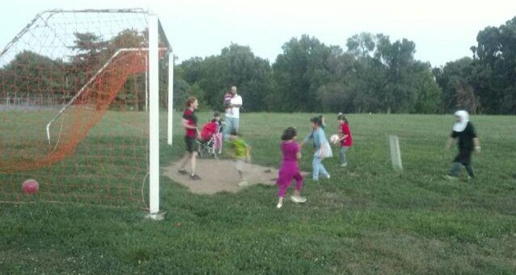
- Ethan met up with his friend of 30 years for camping and sharing life.
- Paula’s mother in-law, Patricia, who has been suffering from cardiac arrhythmias for the past month, underwent a successful cardioversion yesterday. Doing much better.

Closing Prayer: Gail Stewart
Meeting adjourned: 8:40 pm
Next Meeting: Combined meeting with Session -- 13 Sep 2016 @ 6pm

Respectfully submitted,

Cindy Taylor
Clerk of Deacons

Mary Lancaster
Moderator

